A Project report on

Online Hashing with Bit Selection
for Image Retrieval

A Dissertation submitted to JNTU Hyderabad in partial fulfillment of the academic requirements for the award of the degree.

Bachelor of Technology
in
Computer Science and Engineering
Submitted by

B.Thirupathi
(19H51A0532)
K.Vamshi krishna
(19H51A0574)
G.Thriveni
(20H55A0507)

Under the esteemed guidance of
Dr. Vijaya Kumar Koppula
(Professor of CSE & Dean Academics
Dept. of CSE)

Department of Computer Science and Engineering
CMR COLLEGE OF ENGINEERING & TECHNOLOGY
(An Autonomous Institution under UGC & JNTUH, Approved by AICTE, Permanently Affiliated to JNTUH, Accredited by NBA.)

KANDLAKOYA, MEDCHAL ROAD, HYDERABAD - 501401.

2019- 2023

CMR COLLEGE OF ENGINEERING & TECHNOLOGY
KANDLAKOYA, MEDCHAL ROAD, HYDERABAD – 501401

DEPARTMENT OF COMPUTER SCIENCE AND ENGINEERING


CERTIFICATE

This is to certify that the Major Project Phase-II report entitled "Online Hashing with Bit Selection for Image Retrieval" being submitted by B.Thirupathi (19H51A0532), K.Vamshi krishna (19H51A0574), G.Thriveni (20H55A0507) in partial fulfillment for the award of Bachelor of Technology in Computer Science and Engineering is a record of bonafide work carried out his/her under my guidance and supervision.

The results embodies in this project report have not been submitted to any other University or Institute for the award of any Degree.

Dr. Vijaya Kumar Koppula Dr. Siva Skandha Sanagala
Professor of CSE & Dean Academics Associate Professor and HOD
Dept. of CSE Dept. of CSE

ACKNOWLEDGEMENT

With great pleasure we want to take this opportunity to express my heartfelt gratitude to all the people who helped in making this project work a grand success.
We are grateful to Dr. VIJAYA KUMAR KOPPULA, Professor of CSE & Dean Academics, Department of Computer Science and Engineering for his valuable technical suggestions and guidance during the execution of this project work.
We would like to thank Dr. Siva Skandha Sanagala, Head of the Department of Computer Science and Engineering, CMR College of Engineering and Technology, who is the major driving forces to complete my project work successfully.
We are very grateful to Dr. Vijaya Kumar Koppula, Dean-Academic, CMR College of Engineering and Technology, for his constant support and motivation in carrying out the project work successfully.
We are highly indebted to Dr. V A Narayana, Principal, CMR College of Engineering and Technology, for giving permission to carry out this project in a successful and fruitful way.
We would like to thank the Teaching & Non- teaching staff of Department of Computer Science and Engineering for their co-operation
We express our sincere thanks to Mr. Ch. Gopal Reddy, Secretary, CMR Group of Institutions, for his continuous care.
Finally, We extend thanks to our parents who stood behind us at different stages of this Project. We sincerely acknowledge and thank all those who gave support directly and indirectly in completion of this project work.

B.Thirupathi 19H51A0532
K.Vamshi krishna 19H51A0574
G.Thriveni 20H55A0507

Online Hashing with Bit Selection for Image Retrieval

TABLE OF CONTENTS

CHAPTER
NO. TITLE PAGE NO.
LIST OF FIGURES ii
LIST OF TABLES iii
ABSTRACT iv
1 INTRODUCTION 1-2
1.1 Problem Statement 3
1.2 Research Objective 3-4
1.3 Project Scope and Limitations 4
2 BACKGROUND WORK 5
2.1. Online Hashing for Scalable Remote Sensing Image Retrieval 5
2.1.1.Introduction 6
2.1.2.Merits,Demerits and Challenges 7
2.1.3.Implementation of Online Hashing for Scalable
Remote Sensing 8-9
2.2. Scalable Supervised Online Hashing For Image Retrieval 10
2.2.1.Introduction 10
2.2.2.Merits,Demerits and Challenges 11
2.2.3.Implementation of Scalable Supervised Online Hashing 12-13
2.3. Online Hashing with Mutual Information 14
2.3.1.Introduction 14
2.3.2.Merits,Demerits and Challenges 15
2.3.3.Implementation of Online Hashing with Mutual Information 16
3 PROPOSED SYSTEM 17-29
3.1. Objective of Proposed Model 18
3.2. Algorithms Used for Proposed Model 19-21
3.3. Designing 22-24
3.3.1.UML Diagram 25
3.3. Stepwise Implementation and Code 26-39
4 RESULTS AND DISCUSSION 4.1. Performance metrics 40-48

CMRCET B. Tech (CSE) Page No i
Online Hashing with Bit Selection for Image Retrieval

5 CONCLUSION 49
5.1 Conclusion and Future Enhancement 50-51

6 REFERENCES 52-53

GitHub Link

CMRCET B. Tech (CSE) Page No ii

Online Hashing with Bit Selection for Image Retrieval

List of Figures
FIGURE
NO. TITLE PAGE NO.
1.2 Zero shot 4
2.1.1 Scalable Remote Sensor 7
2.1.2 Scalable Remote Sensor 9
2.2.1 Scalable Supervised 11
2.2.2 Scalable Supervised 13
2.3.1 Mutual Information 14
2.3.2 Hashing Mutual information 16
3.3 Designing 22
4 Results 41-43
4.1 Data Collection 44
4.1 Performances metrics 45
4.2 Map-Curve 48

CMRCET B. Tech (CSE) Page No iii
Online Hashing with Bit Selection for Image Retrieval

List of Tables

FIGURE
NO. TITLE PAGE NO.
4.1 Confusion matrix 46
4.1 CIFAR - 10 47

CMRCET B. Tech (CSE) Page No iv
Online Hashing with Bit Selection for Image Retrieval

ABSTRACT
Online hashing methods have been intensively investigated in semantic image retrieval due to their efficiency in learning the hash functions with one pass through the streaming data. Among the online hashing methods, those based on the target codes are usually superior to others. However, the target codes in these methods are generated heuristically in advance and cannot be learned online to capture the characteristics of the data.In this project, we propose a new online hashing method in which the target codes are constructed according to the data characteristics and are used to learn the hash functions online. By designing a metric to select the effective bits online for constructing the target codes, the learned hash functions are resistant to the bit-flipping error. At the same time, the correlation between the hash functions is also considered in the designed metric. Hence, the hash functions have low redundancy. Extensive experiments show that our method can achieve comparable or better performance than other online hashing methods on both the static database and the dynamic database.

CMRCET B. Tech (CSE) Page No v
Online Hashing with Bit Selection for Image Retrieval

CHAPTER 1
INTRODUCTION

CMRCET B. Tech (CSE) Page No 1
Online Hashing with Bit Selection for Image Retrieval
CHAPTER 1
- INTRODUCTION

- Due to the ever-growing amount of multimedia, it is a substantial challenge to retrieve the relevant content from a large multimedia database by performing the nearest neighbor search. As the multimedia data, such as videos and images, are usually represented by high-dimensional feature descriptors conventional nearest neighbor search methods such as tree-based methods cannot deal with the high-dimensional data.

- When new images are adding into the database, the new images entail new label classes, resulting in changes of the data distribution. When fresh data comes, it takes time to recapture the hash functions by collecting all the data. It's also prohibitively costly to learn the hash functions, because of the restricted memory space, by putting the large database at once into memory. In response to the above-mentioned problems, online hashing methods have been created to learn the hash functions online from the increasing data.

There are two-part hash techniques, update hash function and Update binary code online hashing methods. The first section focuses on learning from the data efficient hash algorithms for compact binary codes.The second portion focuses on developing a measure to determine whether all and some binary codes may be changed since the updating of the hash functions is time-consuming and unneeded.

1.1 Problem Statement
Online hashing methods have been intensively investigated in semantic image retrieval due to their efficiency in learning the hash functions with one pass through the streaming data. Among the online hashing methods, those based on the target codes are usually superior to others. However, the target codes in these methods are generated heuristically in advance and cannot be learned online to capture the characteristics of the data.

CMRCET B. Tech (CSE) Page No 2
Online Hashing with Bit Selection for Image Retrieval

1.2 Research Objective

BATCH-BASED HASHING
Locality sensitive hashing (LSH) is one of the representative hashing methods, which generates the hash functions by random projection. However, LSH is a data-independent hashing method and usually needs long binary codes to achieve good search accuracy. Compared to data-independent hashing methods, data-dependent hashing methods can generate compact binary codes by learning the hash functions from the data.The data-dependent hashing methods can be categorized as unsupervised hashing methods and semi-supervised hashing methods. However, the above data-dependent hashing methods are batch-based methods and cannot deal with the new data. When new data arrives, they have to re-learn the hash functions by using all the data, which is time consuming.
ZERO-SHOT HASHING
Zero-shot hashing methods attempt to address the problem of new image classes that are not seen in the training phase due to the insufficient training data. As some image classes are not covered in the training phase, the zero shot hashing methods describe the unseen images by transferring the supervised knowledge from the seen image classes to the unseen image classes There are two ways for the zero-shot hashing methods to transfer supervised knowledge. In the first way they use the class attributes as the mediator and construct a shared attribute space between the seen classes and the unseen classes. In the second way they use the word embedding technique .

CMRCET B. Tech (CSE) Page No 3

Online Hashing with Bit Selection for Image Retrieval

to represent the class concepts, and transfer the knowledge among these classes according to the correlation between their concepts. In either way, the seen classes and the unseen classes should be highly related, and considerable auxiliary information is needed, which limits their applications.

Data Binary Bit Hash Function Hash Functions and
Generation Learning Bit selection

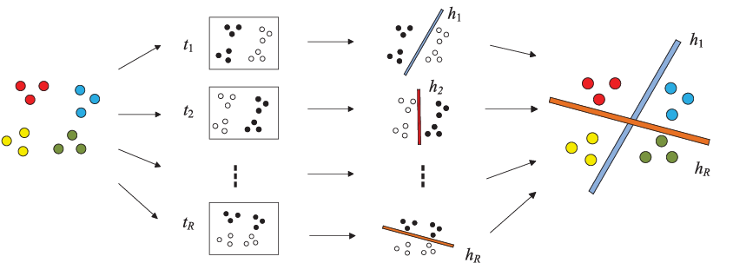

1.3 Project Scope
By designing a metric to select the effective bits online for constructing the target codes, the learned hash functions are resistant to the bit flipping error. At the same time, the correlation between the hash functions is also considered in the designed metric. Hence, the hash functions have low redundancy .

CMRCET B. Tech (CSE) Page No 4
Online Hashing with Bit Selection for Image Retrieval

CHAPTER 2
BACKGROUND WORK

CMRCET B. Tech (CSE) Page No 5
Online Hashing with Bit Selection for Image Retrieval
CHAPTER 2
BACKGROUND WORK
  - Online Hashing for Scalable Remote Sensing Image Retrieval

    - Introduction

The rapid development of satellite and aerial vehicle technologies, we have entered an era of remote sensing (RS) big data. Automatic knowledge discovery from massive RS data has become increasingly urgent. Among emerging RS big data mining efforts, large-scale RS image retrieval has attracted an increasing amount of research interest due to its broad applications in the RS research community. For example, a fast and accurate retrieval of similar satellite cloud images can provide valuable judging information for short-term weather forecasting. Besides, in the disaster rescue scenario, a fast rescue and optimal resources allocating also depend on the real-time and precise retrieval strategies for the photographs of disaster area.

RS image retrieval systems, RS image retrieval mainly relied on manual tags in terms of sensor types, waveband information, and geographical locations of remote sensing images. However, the manual generation of tags is quite time consuming and becomes especially prohibitive when the volume of remote sensing images is oversized. As an effective method to manage a large number of images, content-based image retrieval (CBIR) can retrieve the interesting images according to their visual content. In recent years, content-based RS image retrieval has been comprehensively studied, in which the similarity of RS images is measured by different kinds of visual descriptors. More , local invariant, morphological, textural, and data-driven features have been evaluated in terms of content-based RS image retrieval tasks. To further improve image retrieval performance levels, proposed a multiple feature-based remote sensing image retrieval approach by combining handcrafted features and data-driven features via unsupervised feature learning.

CMRCET B. Tech (CSE) Page No 6
Online Hashing with Bit Selection for Image Retrieval

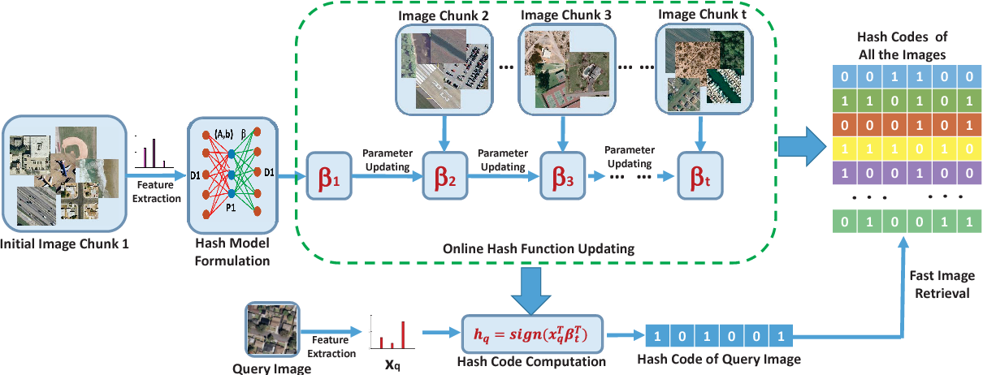

Merits-

Online Hashing for Scalable Remote Sensing Image Retrieval offers the following advantages:

. Efficient and adapts well to long code lengths.
. Effective compact hashing.
. Less memory consumption and calculation cost.
Demerits-

Online Hashing for Scalable Remote Sensing Image Retrieval offers the following disadvantages:

. Training speed very slow Difficult to optimize.
. Slower because of the extraction of SIFT descriptors.

CMRCET B. Tech (CSE) Page No 7
Online Hashing with Bit Selection for Image Retrieval

Challenges-

- hashing approach for real-world large-scale remote sensing image retrieval.
- state-of-the-art for online hashing.

2.1.2 Implementation of Online Hashing for Scalable Remote Sensing Image Retrieval

1:Input: Streaming image data chunk D1,D2,…,Dk, code length r
2:Output: Hash codes H for all the images
3:Randomly generate a projection matrix A∈Rd×r and a bias row vector b∈Rr
4:Compute P1 by P1=g(DT1⋅A+1nb)
5:Compute Q1=PT1P1 and β^1=Q−11PT1DT1
6:fori=2:k do
7:Compute Pi by Pi=g(DTi⋅A+1nb)
8:Update Qi with Equation (8)
9:Update β^i with Equation (9)
10:end
For
11:Compute the hash codes H for the whole database X=[D1,D2,…,Dk] by H=sign(XTβ^Tk).

CMRCET B. Tech (CSE) Page No 8
Online Hashing with Bit Selection for Image Retrieval

Output:

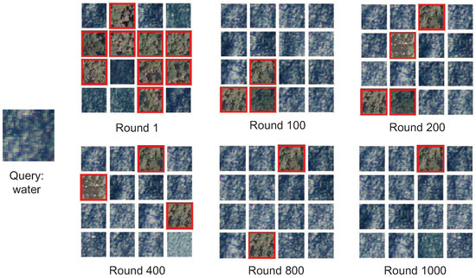

CMRCET B. Tech (CSE) Page No 9

Online Hashing with Bit Selection for Image Retrieval

2.2 Scalable Supervised Online Hashing For Image Retrieval

2.2.1 Introduction

A new loss function is introduced into the supervised online hashing model by constructing a similarity measure between the new data stream and the existing data. Large-scale pairwise similarity calculations are replaced by calculated intermediate variables, which effectively saves calculation costs. The introduction of intermediate variables also effectively alleviates the phenomenon of data imbalance. A discrete optimization algorithm is designed that makes it possible to achieve online discrete optimization.

In the online hashing method, the data will reform along with the change of time, and the model should be updated continuously to cater to the new data. However, the hash code of the historical data stored in the training set is not obtained by mapping using the latest hash function, but received by mapping the hash function at a certain time in the past. Since the hash mapping functions of the data are inconsistent, this may result in a decrease in search accuracy. Therefore, in the research of online hashing methods, it is necessary to balance the influence of historical data and new data on model updates to ensure the accuracy of hash search. Briefly, online hash work mainly focuses on exploring and solving three problems.

CMRCET B. Tech (CSE) Page N0 10
Online Hashing with Bit Selection for Image Retrieval

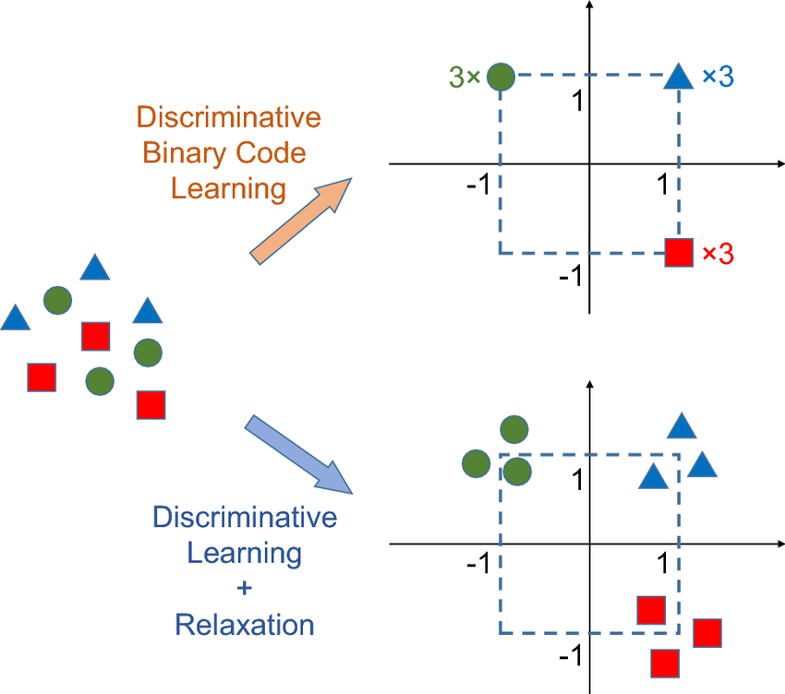

In view of the broad application prospect of hash method in real life, domestic and foreign experts have made a lot of efforts and contributions. Next, we divide the hashing method into offline hashing and online hashing according to the incremental update of the hash model when the research data change dynamically.

Merits:

. Efficient hash functions.
. Higher retrieval accuracy.
. Fast ANN search.

Demerits

. Not sufficient for high - dimensional descriptors.
. Not use all training points due to the complexity.
. Unsatisfactory performance in real-world applications.

CMRCET B. Tech (CSE) Page No 11
Online Hashing with Bit Selection for Image Retrieval

Challenges:

- Retrieve all correct images based on the query image.
- It reflects the differences in the retrieval results of each method to a certain extent.

2.2.2 Implementation of Scalable Supervised Online Hashing For Image Retrieval

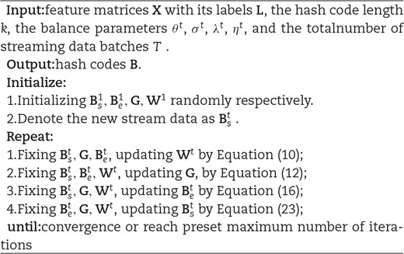

CMRCET B. Tech (CSE) Page No 12
Online Hashing with Bit Selection for Image Retrieval

Output:

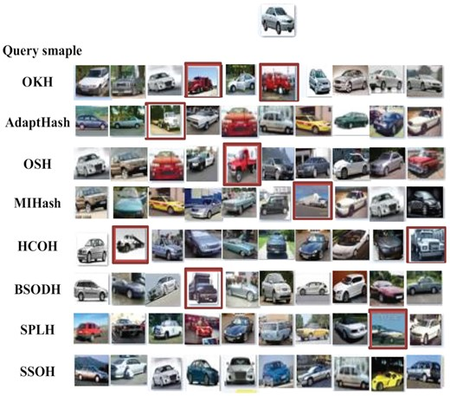

CMRCET B. Tech (CSE) Page No 13
Online Hashing with Bit Selection for Image Retrieval

2.3 Online Hashing with Mutual Information

2.3.1.Introduction

Hashing is a widely used approach for practical nearest neighbor search in many computer vision applications. It has been observed that adaptive hashing methods that learn to hash from data generally outperform data-independent hashing methods such as Locality Sensitive Hashing . In this paper, we focus on a relatively new family of adaptive hashing methods, namely online adaptive hashing methods . These techniques employ online learning in the
presence of streaming data, and are appealing due to their low computational complexity and their ability to adapt to changes in the data distribution.

Despite recent progress, a key challenge has not been addressed in online hashing, which motivates this work the computed binary representations, or the “hash table”, may become outdated after a change in the hash mapping. To reflect the updates in the hash mapping, the hash table may need to be recomputed frequently, causing inefficiencies in the system such as successive disk I/O, especially when dealing with large datasets.

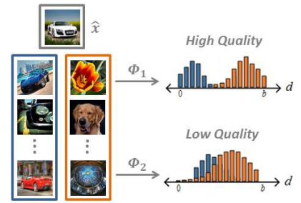

CMRCET B. Tech (CSE) Page No 14
Online Hashing with Bit Selection for Image Retrieval
Merits:
. Highly efficient .
. Very fast and high precision.
. Low storage cost .
.
Demerits :
. Require a significant degree of effort in large-scale applications.
. Expensive training time .
. Insufficient precision rate.
Challenges :
- Mutual information based update criterion, the Trigger Update module (TU).

2.TU can be used to filter updates to the hash mapping with negative or small improvement.

CMRCET B. Tech (CSE) Page No 15
Online Hashing with Bit Selection for Image Retrieval

2.3.2 Implementation of Online Hashing with Mutual Information :

- The goal of hashing is to learn a hash mapping
Φ : X → Hb such that a desired neighborhood structure is preserved.
- We consider an online learning setup where Φ is continuously updated from input streaming data, and at time t, the current mapping Φt is learned from {x1, . . . , xt}.
3. We follow the standard setup of learning Φ from pairs of instances with similar/dissimilar labels
4.These labels, along with the neighborhood structure, can be derived from a metric, e.g. two instances are labeled similar (i.e. neighbors of each other) if their Euclidean distance in X is below a threshold

Output:

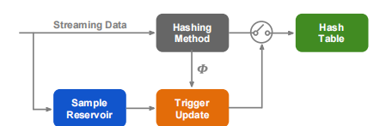

CMRCET B. Tech (CSE) Page No 16

Online Hashing with Bit Selection for Image Retrieval

CHAPTER 3

PROPOSED SYSTEM

CMRCET B. Tech (CSE) Page No 17
Online Hashing with Bit Selection for Image Retrieval

3.1 Objective of Proposed Model

- Different from OSupH(Online Supervised Hashing) and HCOH(Hadamard Codebook based Online Hashing) in which the target codes are generated heuristically and the hash functions are learned collectively according to the generated codes, in our method, the hash functions are learned independently. Hence, the effective target codes can be constructed by selecting the effective bits online to reduce the correlation between hash functions and improve the robustness of hash functions, while the target codes of OSupH and HCOH are generated heuristically only in advance and cannot be learned online. To our knowledge, the existing online hashing methods based on target codes do not support constructing target codes online according to the data.

b. A metric is proposed to select the effective binary bits to construct the target codes. The metric consists of two selection criteria. One selection criterion is designed to select the bits that can make the hash functions resistant to the bit flipping error, and the other one is designed to select the bits that can result in the low correlation between the hash functions. c. We compare our method with other online hashing methods in both a static environment and a dynamic environment,while in prior work online hashing methods are compared in either the static environment or the dynamic environment. Extensive experiments show that our method achieves better search accuracy than other online hashing methods.

CMRCET B. Tech (CSE) Page No 18

Online Hashing with Bit Selection for Image Retrieval

3.2. Algorithms Used for Proposed Model
1. RSA (Rivest, Shamir and Adleman)
2. ONLINE HASHING ALGORITHM
3. BIT SELECTION ALGORITHM

- RSA (Rivest, Shamir and Adleman)
RSA algorithm is a public key encryption technique and is considered as the most secure way of encryption. It was invented by Rivest, Shamir and Adleman in year 1978 and hence name RSA algorithm.

A hashing algorithm is a cryptographic hash function. It is a mathematical algorithm that maps data of arbitrary size to a hash of a fixed size.

Working of RSA Algorithm
- Consider 2 huge prime numbers from image pixels
- p, q such that p ≠q.
- Calculate n= p x q, ϕ(n) = (p-1) (q-1)
- Select e such that gcd(e,ϕ(n))≡1.
- Calculate d using Extended Euclidean algorithm (
- d ≡ e-1 mod (())
- Public key = {e, n}
- Private key = {d, n}
- Encryption .

CMRCET B. Tech (CSE) Page No 19
Online Hashing with Bit Selection for Image Retrieval

ONLINE HASHING ALGORITHM

Online hashing is a technique for generating compact binary codes for images.
These codes can be used to efficiently search large image databases.
Online hashing has several benefits, including fast query times and low storage requirements.

BIT SELECTION ALGORITHM

Bit selection is the process of choosing the optimal number of bits for a hash code
The optimal number of bits depends on the size of the image database and the desired retrieval performance
Different bit selection methods can have a significant impact on image retrieval performance

SHA ALGORITHM

SHA stands for secure hashing algorithm. SHA is a modified version of MD5 and used for hashing data and certificates. A hashing algorithm shortens the input data into a smaller form that cannot be understood by using bitwise operations, modular additions, and compression functions.

CMRCET B. Tech (CSE) Page No 20
Online Hashing with Bit Selection for Image Retrieval

Bit Selection Strategies

● Random Selection: A simple and effective strategy that selects bits randomly from the hash code Easy to implement and computationally efficient May not be optimal for complex datasets.

● Mutual Information-based Selection:
A strategy that selects bits based on their mutual information with the class labels Can improve retrieval performance for structured datasets May require additional supervision and
computational resources.
Hashing Techniques
● Supervised Hashing: A technique that learns hash functions from labeled data
○ Requires labeled data for training
○ Can achieve high retrieval accuracy with sufficient training data
● Unsupervised Hashing: A technique that learns hash functions from unlabeled data
○ Does not require labeled data for training
○ May not achieve high retrieval accuracy without additional supervision

CMRCET B. Tech (CSE) Page No 21
Online Hashing with Bit Selection for Image Retrieval

3.3. Designing
Working:

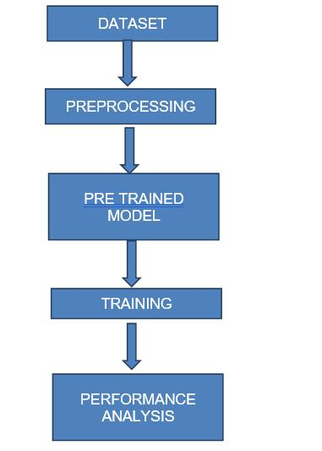

CMRCET B. Tech (CSE) Page No 22

Online Hashing with Bit Selection for Image Retrieval
Use cases :

Image Server
In this module, the Image server has to login by using valid user name and password. After login successful he can do some operations such as View all images with its Description and ranking,View all images ranking,List all users and authorize,List end user transaction,View all similar images with similar hash sign,Find the distance between images,Find all view non similar images based on different hash sign.

Search History
This is controlled by admin; the admin can view the search history details. If he clicks on search history button, it will show the list of searched user details with their tags such as user name, user searched for image name, time and date.
Rank of images
In user’s module, the admin can view the list of ranking images. If admin click on list of ranking images, then the server will give response with their tags image and rank of image.
Upload Images
In this module, the admin can upload n number of images. Admin want to upload new image then he has enter some fields like image name, image color, image description, image type, image usage, browse the image file and upload. After uploading successfully he will get a response from the server. Initially new uploaded image rank is zero. After viewing that image rank will re-rank.

CMRCET B. Tech (CSE) Page No 23
Online Hashing with Bit Selection for Image Retrieval

User

In this module, there are n numbers of users are present. User should register before doing some operations. And register user details are stored in user module. After registration successful he has to login by using authorized user name and password. Login successful he will do some operations like view my details, search images, request secrete key and logout. The user click on my details link then the server will give response to the user with all details such as user name, phone no, address, e mail ID and location. An end user can search the images based on Images based on keyword or hash code and gets the details like image name, image color, image usage and image type. And server will give response to the user, then that image rank will be increased.

CMRCET B. Tech (CSE) Page No 24
Online Hashing with Bit Selection for Image Retrieval

3.3.1.UML DIAGRAM


User
Image Server

Search the Images based on keyword or hashcode
Upload all images

Find the distance between images, Find all view non similar images based on different hash sign history

Click images and view all similar images

View all images data sets
View user details
View all images data sets

Select and click the images
View all image clicked ranking

View all users
View all uploaded images
Enlarge and view images details

CMRCET B. Tech (CSE) Page No 25
Online Hashing with Bit Selection for Image Retrieval

IMPLEMENTATION
Start

USER :

Username & Password Wrong
Login
User Register

YES NO

Search Users

YY
Log Out
View enlarged image

View clicked images details
Search images based on similar Hash Code

YES NO
Search images based on keyword

CMRCET B. Tech (CSE) Page No 26
Online Hashing with Bit Selection for Image Retrieval

Start

Image Server

Server Login

YES
NO
Login

Username & Password Wrong
Browse and upload all images

View all search and click history

List all Users

List Image Data Sets, Find all view non similar images based on different hash sign

View all uploaded Images
View all similar images with similar hash sign,Find the distance between images

CMRCET B. Tech (CSE) Page No 19

CMRCET B. Tech (CSE) Page No 27
Online Hashing with Bit Selection for Image Retrieval

CODE :
<!DOCTYPE html PUBLIC "-//W3C//DTD XHTML 1.0 Transitional//EN" "http://www.w3.org/TR/xhtml1/DTD/xhtml1-transitional.dtd">
<html xmlns="http://www.w3.org/1999/xhtml">
<head>
<title>Image Adding</title>
<meta http-equiv="Content-Type" content="text/html; charset=iso-8859-1" />
<link rel="stylesheet" type="text/css" href="css/style.css" />
<style type="text/css">
<!--
.style1 {color: #7FB600}
.style2 {color: #DD5411}
.style3 {font-size: 15px}
-->
</style>
</head>
<body>
<center>
<div id="wh_bg">
<div id="bd_bg">
<!--top panel starts-->
<div id="main1">
<div id="top"> <span class="what"> <img src="images/what1.gif" width="0.1" height="0.1" alt="" class="wh_img" /> </span> <img src="images/logo1.jpg" width="284" height="60" alt="" class="logo" />
<div class="menu">
<a href="index.html">HOME</a> <img src="images/line.gif" width="3" height="13" alt="" class="flt" style="margin-top:20px;" />
<a href="admin_Login.jsp" style="color:#7FB600;">IMAGE SERVER </a> <img src="images/line.gif" width="3" height="13" alt="" class="flt" style="margin-top:20px;" />
<a href="user_Login.jsp">USER</a> <img src="images/line.gif" width="3" height="13" alt="" class="flt" style="margin-top:20px;" />
<a href="project_Details.html"></a> </div>
</div>
</div>
<div id="main2">

CMRCET B. Tech (CSE) Page No 28
Online Hashing with Bit Selection for Image Retrieval

<div id="wel_bg"> </div>
</div>
<!--top panel ends-->
<!--content panel starts-->
<div id="main3">
<div id="con">
<div id="content">
<div id="left"> <h2 class="style1">Sidebar Menu</h2>
<div class="flt" style="width:260px;padding:15px 0px 0px 9px;">

<li><a href="admin_Main.jsp"style="color:#DD5411;">Admin Main</a> </li></br>
<li><a href="admin_Login.jsp"style="color:#DD5411;">Log Out</a> </li></br>
<p>&nbsp;</p>

</div>

<h2 class="style1">Main </h2>
</div>
<div id="right"> <h2 class="style2" >Upload Image Details . <span class="style1"></span></h2>
<div class="flt" style="width:590px;padding:15px 0px 0px 7px;">
<p></p>
<form action="admin_Add_Images1.jsp" method="post" enctype="multipart/form-data">
<table width="506" border="0" cellpadding="0" cellspacing="0" style="border-collapse: collapse; display:inline; margin:10px 10px 10px 10px; font-family:Verdana, Arial, Helvetica, sans-serif; font-size:14px;">

<%@ page import ="java.util.*" %>
<%@ include file="connect.jsp" %>
<%

CMRCET B. Tech (CSE) Page No 29
Online Hashing with Bit Selection for Image Retrieval

try{
ArrayList a1=new ArrayList();
String str = " select * from titles ";
Statement st = connection.createStatement();
ResultSet rs = st.executeQuery(str);
while(rs.next())
{
a1.add(rs.getString(2));
}
%>

<tr>
<td width="188" valign="middle" height="45" style="color: #2c83b0;"><div align="left" class="style3 style7 style1" style="margin-left:20px;"><strong> Select Title </strong></div></td>
<td width="318" valign="middle" height="45" style="color:#000000;"><div align="left" style="margin-left:20px;">

<select id="s1" name="title">
<option>--Select--</option>
<% for(int i=0;i<a1.size();i++)
{
%>
<option><%= a1.get(i)%></option>

<%}%>
</select>
</div>

<div align="right"> New <a

href="admin_Add_Titles.jsp">Titles</a>?</div></td>

</td>
</tr>

<tr>

CMRCET B. Tech (CSE) Page No 30
Online Hashing with Bit Selection for Image Retrieval

<td width="188" valign="middle" height="45" style="color: #2c83b0;"><div align="left" class="style3 style7 style1" style="margin-left:20px;"><strong> Name </strong></div></td>
<td width="318" valign="middle" height="45" style="color:#000000;"><div align="left" style="margin-left:20px;"><input type="text" name="name"></div></td>
</tr>
<tr>
<td width="188" valign="middle" height="45" style="color: #2c83b0;"><div align="left" class="style3 style7 style1" style="margin-left:20px;"><strong> Color </strong></div></td>
<td width="318" valign="middle" height="45" style="color:#000000;"><div align="left" style="margin-left:20px;"><input type="text" name="color"></div></td>
</tr>
<tr>
<td width="188" valign="middle" height="45" style="color: #2c83b0;"><div align="left" class="style3 style7 style1" style="margin-left:20px;"><strong> Description <br />
</strong></div></td>
<td width="318" valign="middle" height="45"><div align="left" style="margin-left:20px;">
<textarea name="desc"></textarea>
</div></td>
</tr>
<tr>
<td width="188" align="left" valign="middle" height="45" style="color: #2c83b0;"><div align="left" class="style3 style7 style1" style="margin-left:20px;"><strong> Uses </strong></div></td>
<td width="318" align="left" valign="middle" height="45"><div align="left" style="margin-left:20px;"><input type="text" name="uses"></div></td>

<span class="style8 style1"><strong>
</tr>
</strong></span>
<tr>

CMRCET B. Tech (CSE) Page No 31
Online Hashing with Bit Selection for Image Retrieval

<td width="188" align="left" valign="middle" height="74" style="color: #2c83b0;"><div align="left" class="style3 style8 style1" style="margin-left:20px;"><strong>Select Image </strong></div></td>
<td width="318" align="left" valign="middle" height="74" style="color: #2c83b0;">
<div align="left" style="margin-left:20px;"><input type="file" name="pic"></div></td>
</tr>
<div > <tr><td height="45" colspan="2" id="learn_more" align="center" style="color:#FFFFFF;"><input type="submit" value="Submit" style="width:100px; height:25px; background-color:#000000; color:#FFFFFF;"/>&nbsp;&nbsp;<input type="reset" name="Reset" style="width:100px; height:25px; background-color:#000000; color:#FFFFFF;"/></td></tr></div>
</table>
</form>
<%

connection.close();
}

catch(Exception e)
{
out.println(e.getMessage());
}
%>
</p>
<p>&nbsp;</p>
<p align="right" class="style3"><a href="admin_Main.jsp">Back</a></p>
<p align="right" class="style3">&nbsp;</p>
</div>
<br/>
<h2 class="style2" >&nbsp;</h2>
</div>
</div>

CMRCET B. Tech (CSE) Page NO 32
Online Hashing with Bit Selection for Image Retrieval

</div>
</div>
<!--content panel ends-->
<!--footer panel starts-->
<div id="main4">

</div>
<!--footer panel ends-->
</div>
</div>
</center>
</body>
</html>

CMRCET B. Tech (CSE) Page No 33
Online Hashing with Bit Selection for Image Retrieval

<title>User Profile</title>
<meta http-equiv="Content-Type" content="text/html; charset=iso-8859-1" />
<link rel="stylesheet" type="text/css" href="css/style.css" />
<style type="text/css">
<!--
.style1 {color: #7FB600}
.style2 {color: #DD5411}
.style3 {font-size: 15px}
.style4 {font-size: 14px}
.style5 {color: #000000}
-->
</style>
</head>
<body>
<center>
<div id="wh_bg">
<div id="bd_bg">
<!--top panel starts-->
<div id="main1">
<div id="top"> <span class="what"> <img src="images/what1.gif" width="0.1" height="0.1" alt="" class="wh_img" /> </span> <img src="images/logo1.jpg" width="284" height="60" alt="" class="logo" />
<div class="menu">
<a href="index.html">HOME</a> <img src="images/line.gif" width="3" height="13" alt="" class="flt" style="margin-top:20px;" />
<a href="admin_Login.jsp">IMAGE SERVER </a> <img src="images/line.gif" width="3" height="13" alt="" class="flt" style="margin-top:20px;" />
<a href="user_Login.jsp" style="color:#7FB600;">USER</a> <img src="images/line.gif" width="3" height="13" alt="" class="flt" style="margin-top:20px;" /></div>
CMRCET B. Tech (CSE) Page No 34
Online Hashing with Bit Selection for Image Retrieval

</div>
</div>
<div id="main2">
<div id="wel_bg"> </div>
</div>
<!--top panel ends-->
<!--content panel starts-->
<div id="main3">
<div id="con">
<div id="content">
<div id="left"> <h2 class="style1">Sidebar Menu</h2>
<div class="flt" style="width:260px;padding:15px 0px 0px 9px;">

<li><a href="user_Main.jsp"style="color:#DD5411;">User Main</a> </li></br>
<li><a href="user_Login.jsp"style="color:#DD5411;">Log Out</a> </li></br>
<p>&nbsp;</p>

</div>

<h2 class="style1">Main </h2>
</div>
<div id="right"> <h2 class="style2" >User :<span class="style1"> <%=(String)application.getAttribute("user")%></span> Profile</h2>
<div class="flt" style="width:590px;padding:15px 0px 0px 7px;">
<p>

</p>

CMRCET B. Tech (CSE) Page No 35
Online Hashing with Bit Selection for Image Retrieval

<p></p>
<p><table width="547" border="1.5" align="center" cellpadding="0" cellspacing="0" >

<%@ include file="connect.jsp" %>
<%@ page import="org.bouncycastle.util.encoders.Base64"%>

<%

String user=(String )application.getAttribute("user");

String s1,s2,s3,s4,s5;
int i=0;
try
{
String query="select * from user where username='"+user+"'";
Statement st=connection.createStatement();
ResultSet rs=st.executeQuery(query);
if ( rs.next() )
{

CMRCET B. Tech (CSE) Page No 36
Online Hashing with Bit Selection for Image Retrieval

i=rs.getInt(1);
s1=rs.getString(4);
s2=rs.getString(5);
s3=rs.getString(6);
s5=rs.getString(7);
s4=rs.getString(10);
%>
<tr>
<td width="230" rowspan="6" >
<div class="style7" style="margin:10px 13px 10px 13px;" ><a class="#" id="img1" href="#" >
<input name="image" type="image" src="user_Pic.jsp?id=<%=i%>" style="width:200px; height:200px;" />
</a></div> </td>
</tr>

<tr>
<td width="145" valign="middle" height="40" style="color: #2c83b0;"><div align="left" class="style14 style7 style15 style20 style8 style9 style2 style3" style="margin-left:20px;"><strong>E-Mail</strong></div></td>
<td width="164" valign="middle" height="40" style="color:#000000;"><div align="left" class="style23 style9 style10 style4 style5" style="margin-left:20px;"><%out.println(s1);%></div></td>
</tr>
<tr>
<td width="145" valign="middle" height="40" style="color: #2c83b0;"><div align="left" class="style14 style7 style15 style20 style8 style9 style2 style3" style="margin-left:20px;"><strong>Mobile</strong></div></td>

CMRCET B. Tech (CSE) Page No 37

Online Hashing with Bit Selection for Image Retrieval

<td width="164" valign="middle" height="40"><div align="left" class="style23 style9 style10 style4 style5" style="margin-left:20px;"><%out.println(s2);%></div></td>
</tr>
<tr>
<td width="145" align="left" valign="middle" height="40" style="color: #2c83b0;"><div align="left" class="style14 style7 style15 style20 style8 style9 style2 style3" style="margin-left:20px;"><strong>Address</strong></div> </td>
<td width="164" align="left" valign="middle" height="40"><div align="left" class="style23 style9 style10 style4 style5" style="margin-left:20px;"><%out.println(s3);%></div></td>
</tr>
<tr>
<td width="145" align="left" valign="middle" height="40" style="color: #2c83b0;"><div align="left" class="style14 style7 style15 style20 style8 style9 style2 style3" style="margin-left:20px;"><strong>Date of Birth</strong></div> </td>
<td width="164" align="left" valign="middle" height="40"><div align="left" class="style23 style9 style10 style4 style5" style="margin-left:20px;"><%out.println(s5);%></div></td>
</tr>
<tr>
<td width="145" align="left" valign="middle" height="51" style="color: #2c83b0;"><div align="left" class="style14 style7 style15 style20 style8 style9 style2 style3" style="margin-left:20px;"><strong>Status</strong></div ></td>
<td width="164" align="left" valign="middle" height="51" style="color: #2c83b0;"><div align="left">
<div align="left" class="style23 style9 style10 style4 style5" style="margin-left:20px;"><%out.println(s4);%></div></td>
</tr>

CMRCET B. Tech (CSE) Page No 38
Online Hashing with Bit Selection for Image Retrieval

<%
}
connection.close();
}
catch(Exception e)
{
out.println(e.getMessage());
}
%>
</table></p>
<p>&nbsp;</p>
<p align="right" class="style3"><a href="user_Main.jsp">Back</a></p>
<p>&nbsp;</p>

</div>
<img src="images/cn_bar.gif" width="605" height="1" alt="" class="flt" style="margin-top:15px;" />
<br/>
<h2 class="style2" >Image </h2>
</div>
</div>
</div>
</div>
<!--content panel ends-->
<!--footer panel starts-->
<div id="main4">
<html>

CMRCET B. Tech (CSE) Page No 39
Online Hashing with Bit Selection for Image Retrieval

CHAPTER-4

RESULTS
&
DISCUSSION

CMRCET B. Tech (CSE) Page No 40
Online Hashing with Bit Selection for Image Retrieval

Results

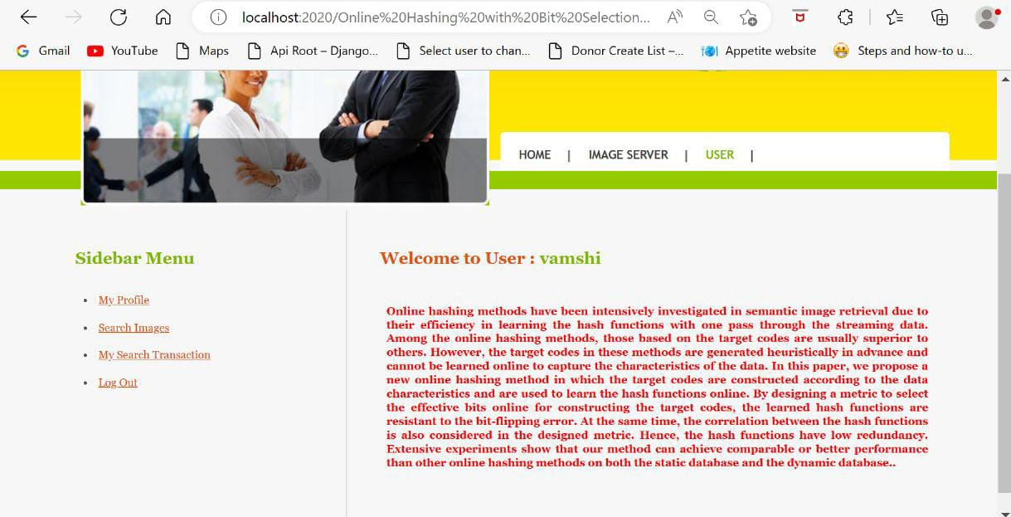

CMRCET B. Tech (CSE) Page No 41
Online Hashing with Bit Selection for Image Retrieval

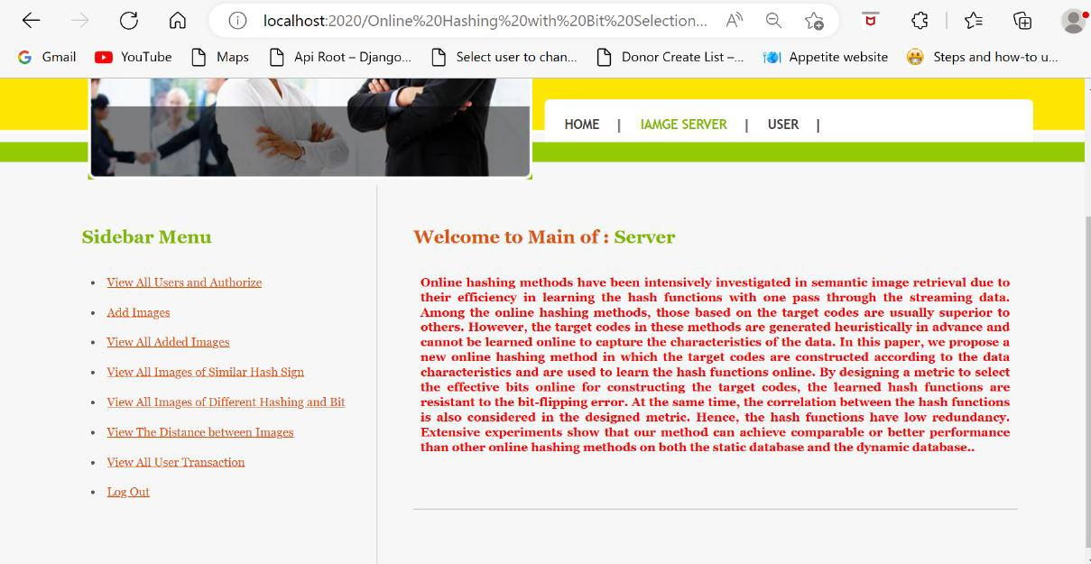

CMRCET B. Tech (CSE) Page No 42
Online Hashing with Bit Selection for Image Retrieval

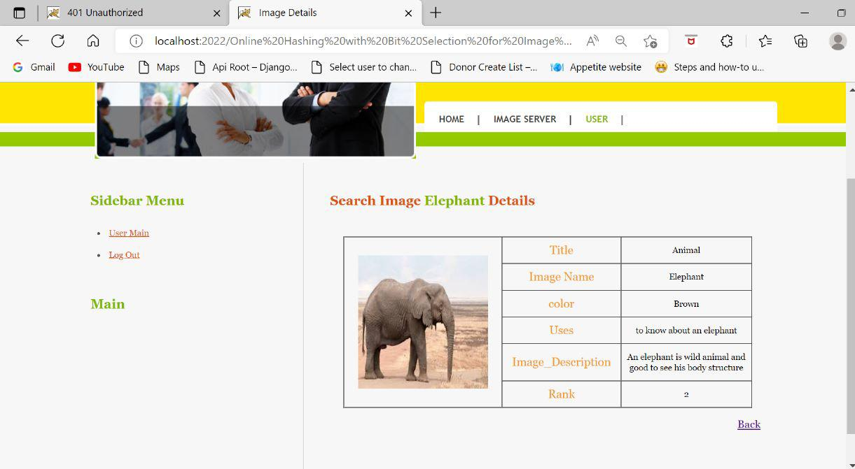

CMRCET B. Tech (CSE) Page No 43
Online Hashing with Bit Selection for Image Retrieval
4.1. Data Collection and Performance metrics

Admin

Add images with hash sign based on image name

System

View all images, Click on images, Find its rank,Click and large Image, View Similarity of the images based on similar Hash code

View all images with its Description and ranking,View all images ranking, List all users and authorize,List end user transaction,View all similar images with similar hash sign Find the distance between images Find all view non similar images based on different hash sign

Search Images based on Keyword or Based on Hash Code

End User

CMRCET B. Tech (CSE) Page No 44
Online Hashing with Bit Selection for Image Retrieval

- Precision: The fraction of retrieved images that are relevant to the query.
- Recall: The fraction of relevant images that are retrieved by the system.
- F1 Score: The harmonic mean of precision and recall.
- These metrics are used to evaluate the effectiveness of online hashing with bit selection for image retrieval.

- various performance metrics that can be used to evaluate predictions for classification
problems.

- Confusion Matrix
- Accuracy
- Precision
- Recall

Hashing Model Hash code
Training
Labels
Human
Computer
Souces classes

Shared parameters
Lables
Target classes

CMRCET B. Tech (CSE) Page No 45
Online Hashing with Bit Selection for Image Retrieval

1.CONFUSION MATRIX

Total samples tested= 165

Predicted Values
Actual Values
TP=100 | FP=5
FN=100 | TN=50

2. ACCURACY = TP+TN
T.S
= 100+50
165
= 0.91
3. PRECISION =
TP
TP+FP
= 100
100+5
= 0.95
6. RECALL =
TP
TP+FP
= 100
100+10
= 0.909

CMRCET B. Tech (CSE) Page No 46
Online Hashing with Bit Selection for Image Retrieval

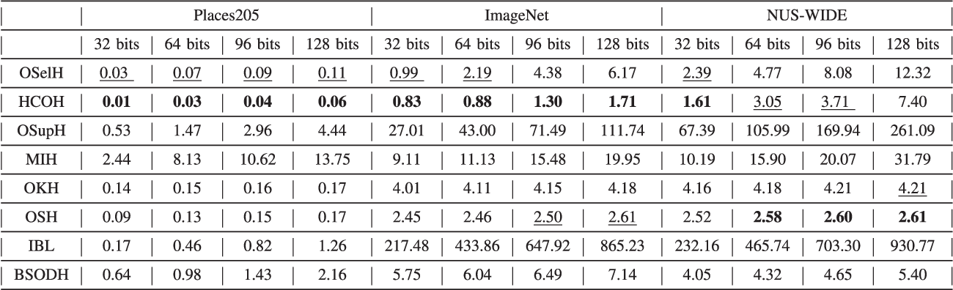

CMRCET B. Tech (CSE) Page No 47
Online Hashing with Bit Selection for Image Retrieval

4.2
Map-Curve

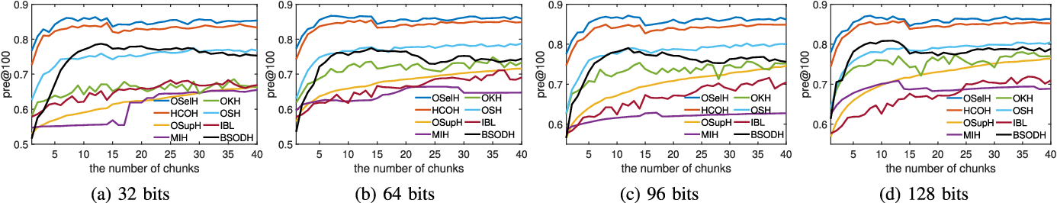

CMRCET B. Tech (CSE) Page No 48
Online Hashing with Bit Selection for Image Retrieval

CHAPTER-5

CONCLUSION

CMRCET B. Tech (CSE) Page No 49
Online Hashing with Bit Selection for Image Retrieval
CHAPTER-5
CONCLUSION
Different from other online hashing methods that generate the target codes heuristically in advance and learn the hash functions collectively according to the target codes, our proposed online supervised hashing method learns the hash
functions independently. As the hash functions are learned independently, the target codes can be constructed online by selecting the effective bits, and the hash functions can be learned according to the constructed target codes. A metric is designed to select the hash functions that have high robustness to resist the bit-flipping error and have low redundancy.

The experiments show that the proposed method can achieve comparable or better performance compared with other online hashing methods on both the static database and the dynamic database.

CMRCET B. Tech (CSE) Page No 50

Online Hashing with Bit Selection for Image Retrieval

FUTURE ENHANCEMENT

Online hashing with bit selection faces several challenges, including reduced accuracy compared to other methods and the need for careful selection of performance metrics.Future directions for research in this area include the development of new online hashing algorithms and bit selection techniques and the exploration of new applications for online hashing with bit selection.

CMRCET B. Tech (CSE) Page No 51

Online Hashing with Bit Selection for Image Retrieval

REFERENCES

CMRCET B. Tech (CSE) Page No 52
Online Hashing with Bit Selection for Image Retrieval

REFERENCES

[1] A. Oliva and A. Torralba, “Modeling the shape of the scene: A holistic representation of the spatial envelope,” International Journal of Computer Vision, vol. 42, no. 3, pp. 145–175, 2001.
[2] A. Krizhevsky, I. Sutskever, and G. E. Hinton,“Imagenet classifification
with deep convolutional neural networks,” in Advances in Neural Information Processing Systems, 2012, pp. 1097–1105.
[3] C. Silpa-Anan and R. Hartley, “Optimised kd-trees for fast image descriptor matching,” in Proceedings of the IEEE Conference on Computer Vision and Pattern Recognition, 2008, pp. 1–8.
[4] J. Tang, Z. Li, and X. Zhu, “Supervised deep hashing for scalable face image retrieval,” Pattern Recognition, vol. 75, pp. 25 – 32, 2018.
[5] C. Deng, Z. Chen, X. Liu, X. Gao, and D. Tao, “Triplet-based deep hashing network for cross-modal retrieval,” IEEE Trans. on Image Processing, vol. 27, no. 8, pp. 3893–3903, Aug 2018.
[6] Q. Jiang, X. Cui, and W. Li, “Deep discrete supervised hashing,” IEEE Trans. on Image Processing, vol. 27, no. 12, pp. 5996–6009, Dec 2018.
[7] Y. Cao, B. Liu, M. Long, and J. Wang, “Hashgan: Deep learning to hash with pair conditional wasserstein gan,” in Proceedings of the IEEE Conference on Computer Vision and Pattern Recognition, June 2018, pp. 1287–1296.
[8] E. Yang, C. Deng, C. Li, W. Liu, J. Li, and D. Tao, “Shared predictive cross-modal deep quantization,” IEEE Trans. on Neural Networks and Learning Systems, vol. 29, no. 11, pp. 5292–5303, Nov 2018.
[9] F. Cakir, S. A. Bargal, and S. Sclaroff, “Online supervised hashing,”
Computer Vision and Image Understanding, vol. 156, pp. 162–173,
2017.

CMRCET B. Tech (CSE) Page No 53

